Puppy Development Coordinator
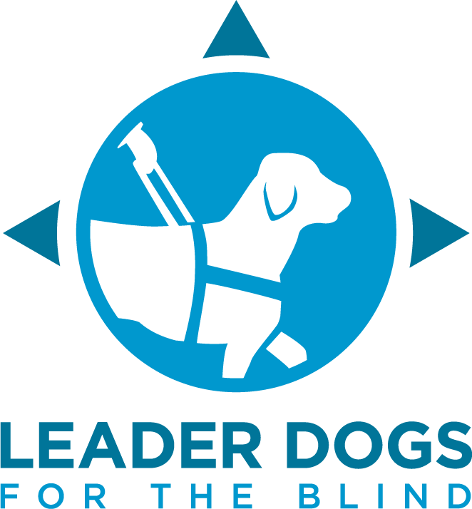
Position Description

Department: Puppy Development
Reports to: Canine Development Manager

Salary: $54000.00 - $60000.00

Leader Dogs for the Blind, an international organization based in Rochester Hills, Michigan, has been empowering individuals who are blind or low vision for over 85 years. We provide comprehensive guide dog services and orientation and mobility training, equipping individuals with lifelong skills for safe and independent daily travel. Our life-changing work is provided free of charge, and we are 100% philanthropically funded. Our mission is driven by 191 dedicated team members and more than 1,000 volunteers who advocate alongside our clients to create a more equitable world.

Why work at Leader Dogs for the Blind?
- Medical, Dental and Vision Insurance after 30 days of employment
- Employer paid life insurance
- Employer paid disability insurance
- 401k with employer match
- Flexible spending account
- Paid time off front loaded on first day of employment
- Annual merit-based pay increases
- Dog friendly office

SUMMARY
The Puppy Development Coordinator is responsible for supporting Leader Dog puppy raising programs and enhancing the puppy raising experience through community-based initiatives and education.

ESSENTIAL DUTIES AND RESPONSIBILITIES
- Establishes and manages ongoing relationships with all forms of community-based raiser groups.
- Determines appropriate placement for puppies according to established organizational guidelines
- Travels to community-based programs, distant, and local puppy raiser groups.
- Consult, support, and strive to provide a positive experience for individual puppy raiser groups, including campus, prison, local and distant raisers.
- Proactively address puppy raiser concerns throughout their volunteer experience
- Ensures that puppy raisers meet established guidelines with individual support and education.
- Oversees the development and training of volunteer puppy counselors to effectively support puppy raisers
- Facilitates training programs for puppy raisers in all raiser environment settings.
- Unwavering commitment to quality programs and data driven program evaluation.
- Coordinates with business liaisons to maintain and distribute supplies needed for puppies
- Coordinates scheduling of puppy pick up and returns
- Uses puppy counselor questionnaires and assessments to prepare data for review and recommend changes based on results
- Provides philanthropic support and coordination with appropriate departments to assist with public relations as it relates to the puppy program
- Responsible for ensuring meaningful volunteer experiences within puppy development department
- Performs other duties as assigned

EDUCATION AND EXPERIENCE

One to three years of experience in teaching, working with people, understanding animal behavior, and dog training. Experience as a Guide Dog Mobility Instructor is desired.

KNOWLEDGE, SKILLS AND ABILITIES

- Ability work well under pressure, handle multiple priorities, meet deadlines, and work independently
- Possesses a valid driver’s license without restrictions and the ability to travel frequently
- Possesses excellent customer service and problem-solving skills
- May be required to be on campus when deemed necessary at the direction of management
- Proficiency in latest version of Microsoft Office products
- Possesses sound business judgment, exercise professional conduct, understand and follow business ethics and standards, and maintain a high level of confidentiality in all duties
- Comfortable working within and around correctional facilities, universities and other community-based venues
- Comfortable working with and around puppies and large dogs
- Must be willing to perform general public relations duties on behalf of Leader Dog (perform tours, answer general questions, be a professional and courteous representative of Leader Dog, etc.)
- Must be able to establish and maintain professional, productive and courteous interactions with employees that promote positive teamwork, as well as with volunteers, donors, clients and all constituents of Leader Dog. This encompasses going beyond giving and receiving instructions and includes but is not limited to (a) performing work activities requiring interacting or speaking with others; and (b) responding appropriately to constructive feedback or suggestions for improvement from a supervisor.

PHYSICAL DEMANDS
The physical demands described below are representative of those that must be met by an employee to successfully perform the essential functions of this job. Upon receiving notice, reasonable accommodations may be made, if possible, to enable individuals with disabilities to perform the essential functions.

While performing the duties of this job, the employee is regularly required to sit, stand, walk, bend, crouch, kneel and reach with hands and arms. While performing the duties of this job, the employee is regularly required to communicate and exchange accurate information using various methods including in-person, telephone and email. The employee must regularly lift and/or move up to 25 pounds and occasionally lift and/or move up to 75 pounds.

Leader Dogs for the Blind reserves the right to change, amend, add, delete, and otherwise assign any and all duties, responsibilities and position title as it deems necessary to meet the needs of its business.

Leader Dogs for the Blind is an at-will employer. This means that the employment relationship may be ended at any time without notice by the employer or employee for any reason. Neither this document, nor any manual issued by Leader Dogs for the Blind, is a contract of employment.

Apply on our website at
https://www.paycomonline.net/v4/ats/web.php/portal/432B00859E877B824B2E13516B0D737A/jobs/312118

